Southampton Marine &  Maritime Institute | 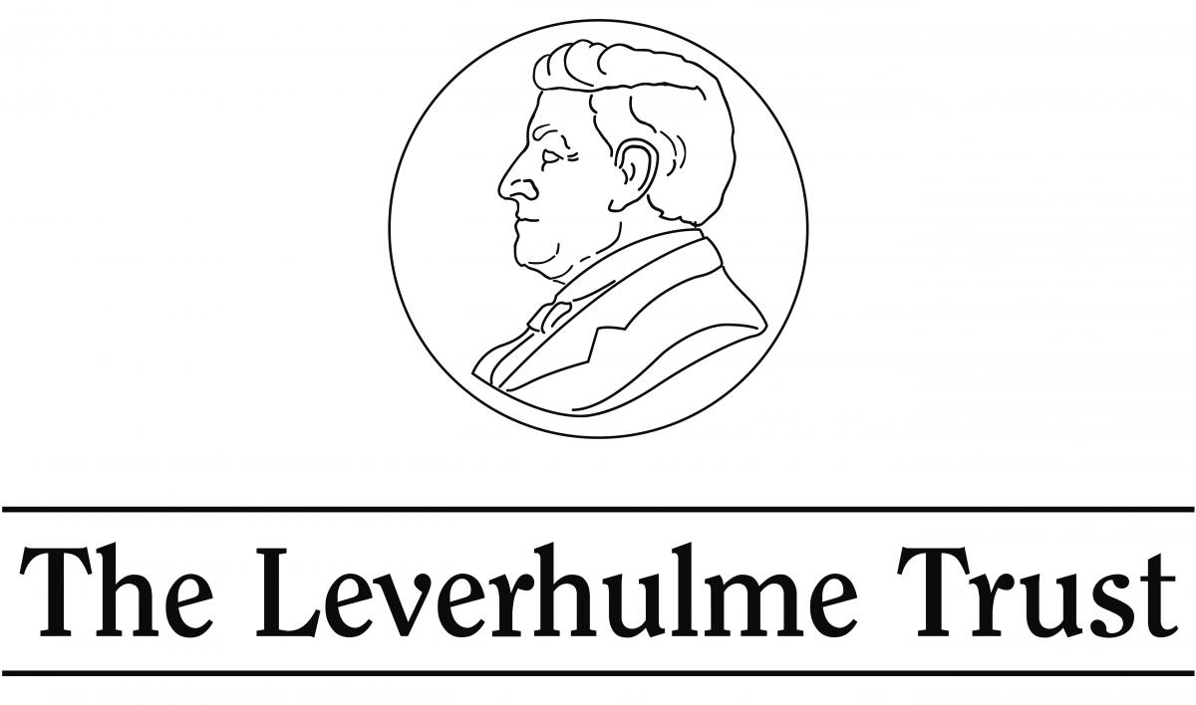

LEVERHULME TRUST DOCTORAL SCHOLARSHIPS
UNDERSTANDING MARITIME FUTURES: OPPORTUNITIES, CHALLENGES, THREATS
PROJECT DESCRIPTION FORM
2016

Please complete the form below and submit to Sue Smith, SMMI Co-ordinator, at s.b.smith@soton.ac.uk by the application deadline of 5pm 27th November 2015. All criteria should be met as set out in the attached guidelines.

Research Project Title:

SMMI-LTDS PROJECT SUPERVISORY TEAM DETAILS:
SMMI Member Name (1):
Faculty & Academic Unit:
Email:
SMMI Member Name (2):
Faculty & Academic Unit:
Email:
SMMI Member Name (3):
Faculty & Academic Unit:
Email:
External Supervisor Name (1):
Organisation and position:
Email:
Add more as required.

Please attach:
• A two page CV including recent publications and funding for each Supervisor.

SMMI-LTDS Understanding Maritime Futures STUDENTSHIP DETAILS 2016 Entry
Studentship Start Date: | October 2016

Rationale (max. 300 words):
Project’s transdisciplinary nature and relevance to the Understanding Maritime Futures LTDS Programme (max. 200 words):
Methodology (max. 200 words):
Training (max. 200 words):
Details of external partners and their input to the project (max. 150 words):
Wider implications, Impact, and future funding potential (max 150 words):
Background reading (max. 3 references):
Details of Additional Funding or Support:

P.I. Signature | Signature: …………………………………………………  Date: ………………………………………………………

Faculty authorising signature  (e.g. Associate Dean for Research /Director of Graduate School) | Signature: …………………………………………………  Date: ………………………………………………………

Please return completed application form as a single pdf file including all CVs and electronic signatures by 5pm 27th November 2015 to Sue Smith at s.b.smith@soton.ac.uk. Southampton Marine & Maritime Institute, Building 176, Room 3043, Boldrewood Campus, Tel: 023 8059 2316; http://www.southampton.ac.uk/smmi

