Doing Research Inclusively, Doing Research Well?

Project information |  | Extra information and images
What is the project?  The aim of the Research Project is to explore what makes good research with people learning disabilities.  The research questions are:  1) What does it mean for people with and without learning disabilities to work in partnership on research? |  | For example, does it involve sharing control of everything in the research? Or does it mean developing methods which enable people with learning disabilities to contribute to research?
2) What kinds of knowledge have inclusive research projects produced? |  | For example knowledge about the past, people’s lives today or about ideas and theories?  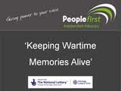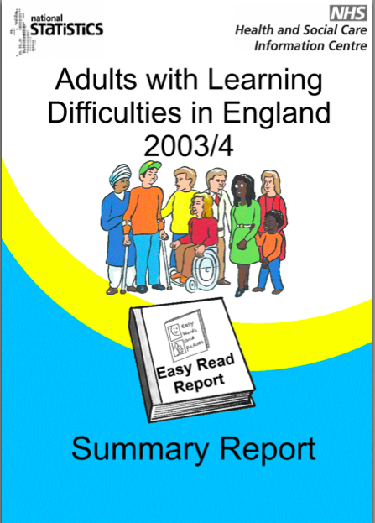  Ideas
3) How do we judge whether research is good research? |  | For example, does the way we judge good research change depending on who’s doing the research?  What makes research good?
4) What are the benefits of inclusive research to people with learning disabilities, their friends and families and people who work with them? |  | For example, does research where people with learning disabilities take the lead produce more useful research?  Is the research produced in inclusive ways more accessible?  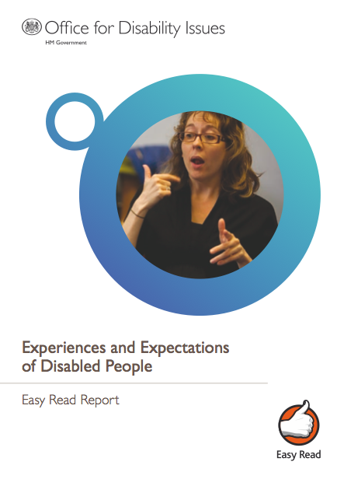  Does inclusive research bring other kinds of benefits such as jobs in universities for people with learning disabilities?  JOBS ££££?
5) What are the pros and cons of different kinds of research? |  | Cons  Prossss
6) When the ESRC fund research they expect researchers to do ‘good research’ – to take all the relevant things into account, to be able to say why you have done the things you have done and to show how these turned out to be good choices.  When people with learning disabilities do research, or take part in research, they expect the research to be focused on making their voices heard, to be relevant to their lives, and to be understandable.  Can these expectations come together? If so, how? |  | £££££  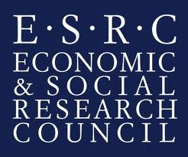  Is the research good ?  Relevant!  Our voices!  Accessible!
7) Finally, how can sharing our experiences and ideas add to our and other people’s understanding of different kinds of research? |  | Sharing ideas
We will use what we learn from the discussions to develop papers for academic journals and to develop materials to support people who do research and who commission (start up and fund) or review (judge) research related to people with learning disabilities. |  | 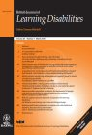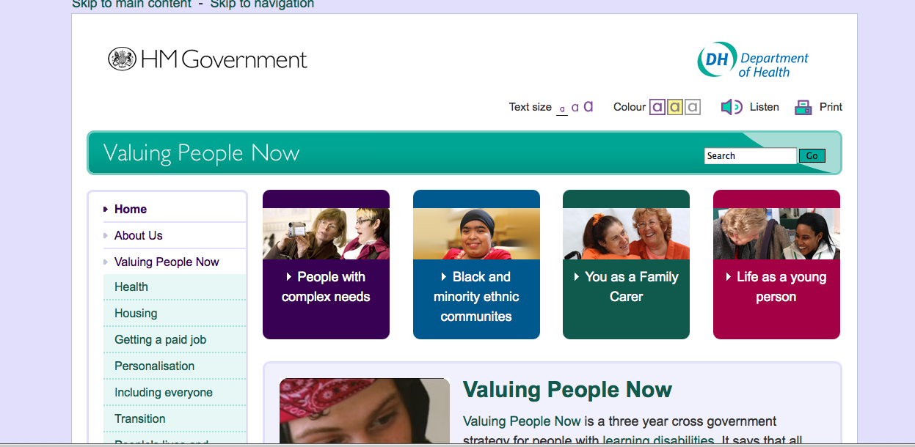
How has the project come about? Who is running the project?  Melanie Nind had the idea for the project after discussions over the years with researchers with and without learning disabilities. Melanie applied to the Economic and Social Research Council for funding to support the project and was successful.  Helen Graham is working with Melanie on the project at the University of Southampton. She has worked with people with learning disabilities on projects about the history of day centres, the experience of living in Supported Living, on access to museums and on art in Newcastle. |  | Melanie  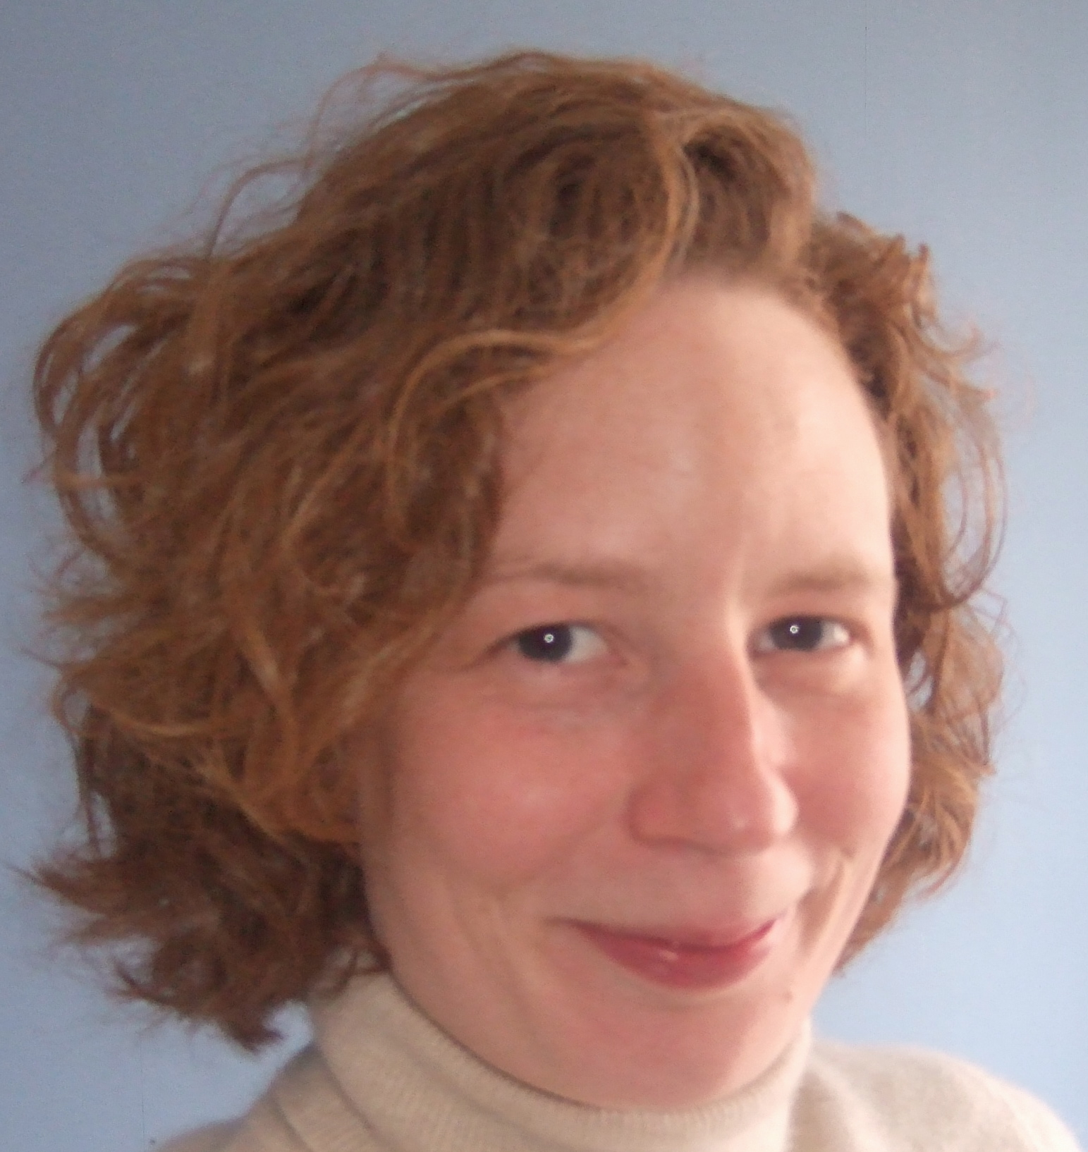 Helen
How is the project going to work?  The project is based on three different groups (called focus groups) who will meet together three times to discuss questions and ideas. These discussions will be audio (sound) recorded and then Melanie and Helen will think about the discussions and share the key ideas around the groups. |  | 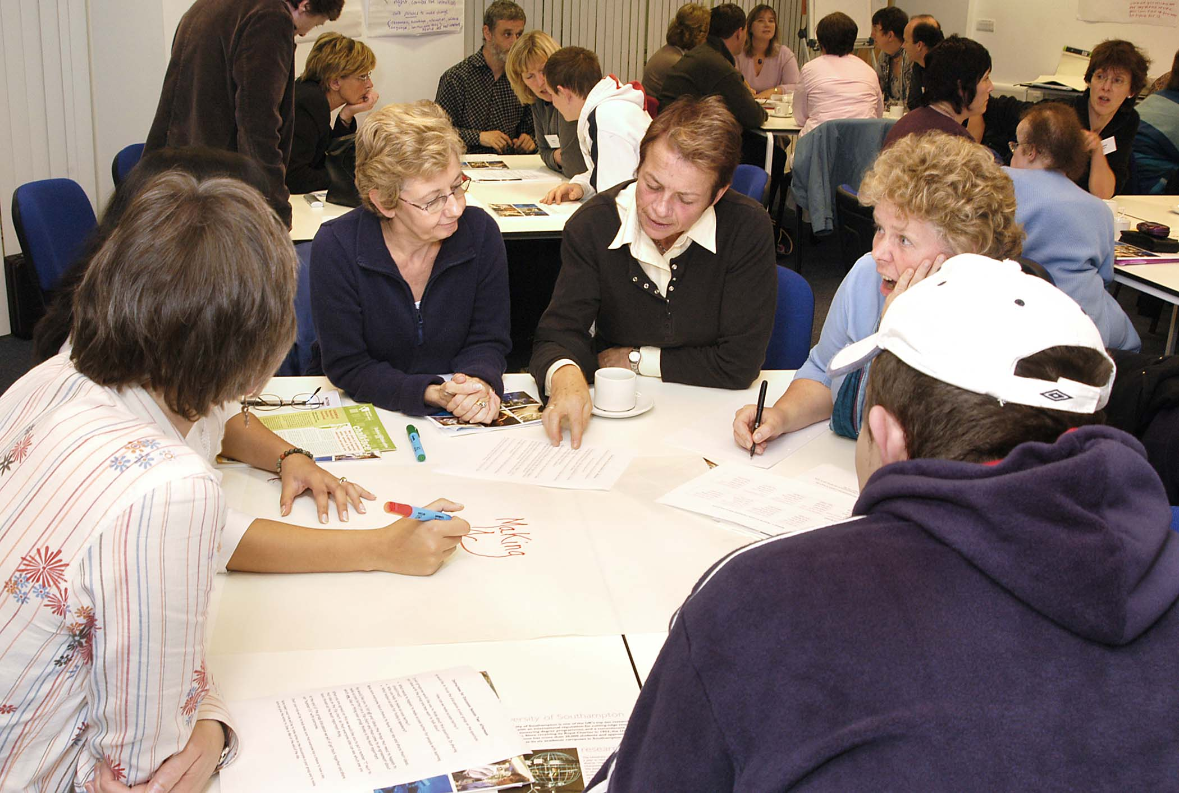  Think about discussions
Everyone who gets involved can choose which group suits them best.  Group 1: Researchers with learning disabilities who lead research projects (with or without support from academic researchers or support workers).  - Group 2: Researchers with and without learning disabilities who work on collaborative projects as co-researchers.  - Group 3: Researchers without learning disabilities who collect data (information) from people with learning disabilities using methods that may help their active participation.  The idea of the three groups is so that people can discuss the issues in small groups with people who work in a similar way. |  | Group 3  Group 2  Group 1
When will the group discussions take place?

The first focus group meeting will take place in June/July 2011, the second in September/October 2011, and the third in December/January 2011-12. There will also be an extra group with policy makers and commissioners of research in March 2012 and a chance for everyone who has been involved to meet together in April.

Where will the group discussions take place?  This depends on who gets involved. Possible locations include Manchester, Bristol or London. We will try to find pleasant, convenient and accessible places to meet because we want this project to be enjoyable as well as interesting for everyone involved.  All your travel costs will be paid for by University of Southampton from the grant. |  | 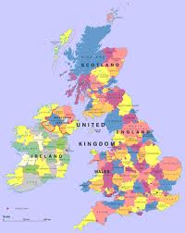  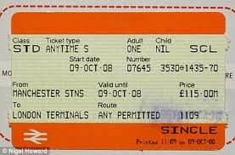  All paid for!
Interested in hearing more? Contact:
Helen Graham
Research Fellow
School of Education
University of Southampton

h.graham@soton.ac.uk / 07855 790347

