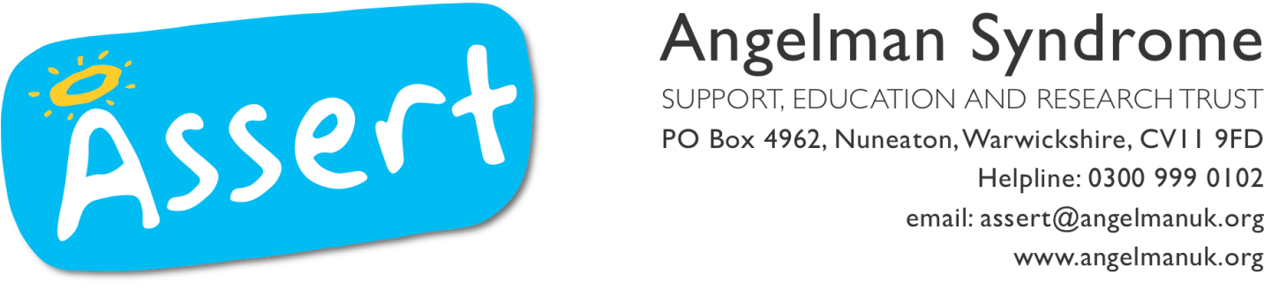

01/05/14

Dear Sir or Madam,

We are very excited to announce that we are inviting calls for a grant to support research into Angelman Syndrome. Please see the specific details below. Please forward this to colleagues who might be interested in applying.

If you have queries about ASSERT and how we hope to support research in the future please contact me, otherwise please follow the instructions within the call.

Best wishes,

Dr Katie Cunnea
Science and Research Trustee, ASSERT
katie.cunnea@angelmanuk.org

Call for Applications for Research Grants on Angelman Syndrome

The Angelman Syndrome Alliance (ASA) supports research on Angelman syndrome with up to a quarter million Euro to be awarded at our annual meeting in Paris. The Angelman Syndrome Alliance is (currently) an initiative of the following parent organisations ORSA (Italy), ASFA (France), ASSERT (United Kingdom), AIA (Ireland), PWAV (Netherlands), vzwASB (Belgium) and the Nina Foundation who is a consortium organisation on AS science. Their mutual aim is to join forces and funds to increase the financial support of dedicated research projects and thereby intensify research on Angelman Syndrome.

Angelman Syndrome is a genetic disorder that results from a loss of UBE3A gene activity which encodes the ubiquitin E3 ligase E6-AP. Angelman Syndrome is characterised by severe intellectual disability, lack of speech, motor coordination deficits, sleep disturbance, and usually a happy demeanor.

Applications for research grants may cover preclinical (basic) research as well as translational research such as mechanism based controlled trials. Applications for behavioral therapies are not eligible at this point.

Proposals addressing new ideas/concepts about the pathogenesis of Angelman syndrome are particularly invited.

Researchers are encouraged to apply from those European countries where parent organisations participate in the strategic alliance to foster research towards a better understanding of Angelman syndrome.

Grants will be awarded for up to €200,000 per grant. The duration of the grant is flexible, but the maximum is 4 years. There will be an evaluation of the project after completion of 50% of the total time with interim reporting each six months.

The application procedure is two-step: first, a short application has to be submitted (Deadline 1st June); a detailed application will then be invited in the beginning of July from those proposals passing step 1 (Deadline 1st of September). The awardees will receive the grant at the bi-annual meeting of the Angelman Syndrome Alliance in October and will be expected to give an ASA-AWARD LECTURE.

The short application should include the following:
- Coverletter including the title of the proposal and the name of the principal investigator.
- Two-page summary of the proposed research including paragraphs on the hypothesis, background, research plan, principal methodology, and the significance of the proposed research. An overview of the budget must also be included (indirect costs cannot be applied for).
- Curriculum vitae of the applicant.

All applications should be written in English language using Times New Roman, 11 point, 1.5 spaced.

Proposals involving laboratory animal testing must be approved by the respective institutional review boards before funding can be released.

The application deadline is June 1st, 2014. All proposals, including cover letters, should be emailed as a single pdf file to two email addresses: betty.willemsen@ninafoundation.eu and as.alliance.grant@gmail.com.

Questions about the process of the grant should be directed to the NINA Foundation at: martijn.van.steensel@ninafoundation.eu

Questions about research on Angelman Syndrome should be directed at: harald.sitte@meduniwien.ac.at

Betty Willemsen and Martijn van Steensel are part of the scientific AS organisation named ‘Nina Foundation’ who is organising the call on behalf of the Angelman Syndrome Alliance (ASA) and Harald Sitte is the chairman of the ASA Scientific Advisory Board (SAB).

