Our MSc course in Unmanned Vehicle Systems Design has been running for 3 years now.
BEng Meng courses in aerospace engineering have significant unmanned systems design content including:-
- Year 2 students have to design build and fly a vehicle with an Arduino based flight data recorder
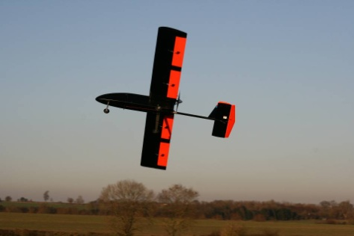
- Year 3 students undertake an individual project to design and build a sophisticated unmanned system

- Year 4 students participate in a project to build a large unmanned system.
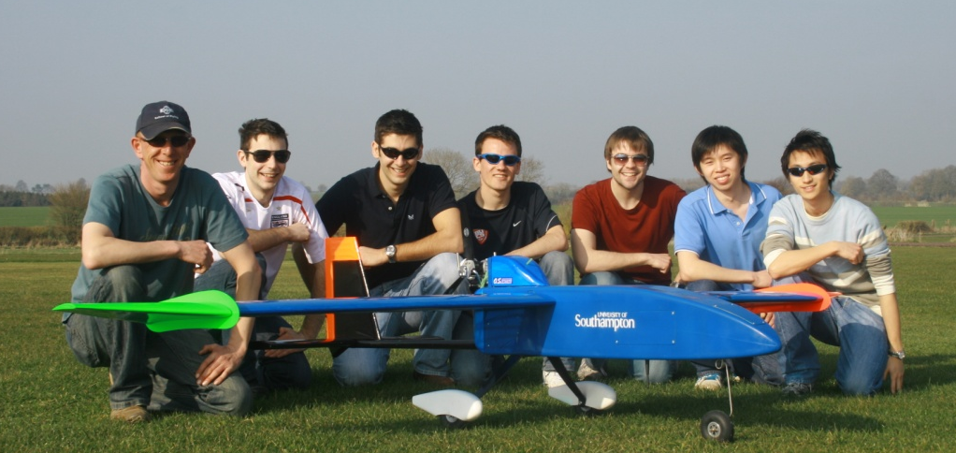

.
The University of Southampton has very strong links with industry. It is unique in the UK in having two UTCs (University Technology Centre) with Rolls-Royce and one UTC with Airbus. Our aerospace students are thus able to join such companies having had the relevant training and experience through internships and placements.
Course leader: Dr Zhiwei Hu Email: Z.Hu@soton.ac.uk

