Event: | Alumni Lecture – Rosemary Squire OBE – Thursday 26 February 2015
From: | Tracy Storey, Faculty Operating Service, Humanities | Date: | 24/02/2015

Many thanks for registering to attend this event, if you are now unable to attend I would be grateful if you could let me know asap. Please follow the guidelines below.

Overview | Rosemary Squire OBE will be giving this year’s Stonewall Lecture. The lecture will be chaired by Professor Anne Curry.  Please join us for refreshments before the lecture.
Programme | 5:30-6:00pm  6:00-7:15pm  7:15pm | Tea and coffee served in the North Corridor  ‘From Woking to the World' in Lecture Theatre A  Event ends
Venue | Lecture Theatre A  Avenue Campus  University of Southampton  SO17 1BF
Instructions | Parking  Free parking is be available on the Avenue Campus  Directions to Avenue Campus (SO17 1BF)  By car, from the north  Take junction 14 of the M3  Follow signs for the A33 into Bassett Avenue towards Southampton  Avenue Campus is signposted on your left.  By car, from the east or west  Take junction 5 (Southampton Airport) of the M27  Follow the A335 (Stoneham Way) towards Southampton and the A35 (Burgess Road)  turn left onto A33 (The Avenue) towards the University  Avenue Campus is signposted on your left.  Rail Travel  Fast trains from London and Bournemouth/Weymouth stop at Southampton Central and Southampton Airport Parkway.  Trains from Portsmouth and Bristol/South Wales stop at Southampton Central. There are taxi ranks at both stations.

Map | Please use the entrance at Main Reception  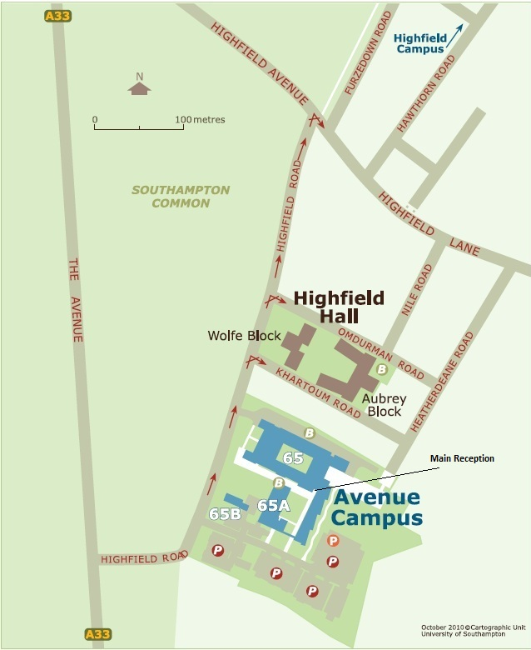
Useful Numbers | Taxi numbers:  West Quay Cars: 023 8099 9999  Radio Taxis: 023 8066 6666 (Central)  ATS: 023 8022 2222 (Central)  Eastleigh Cabs: 023 8065 1111 (Parkway)  National Rail Enquiries:  Tel: 08457 48 49 50  www.nationalrail.co.uk  Uni-link:  Tel: 023 8059 5974  www.uni-link.info
Further information | If you have any further queries please contact Tracy Storey on 023 8059 4861 or email on tps@southampton.ac.uk

