Intelligent Sensing to Promote Self-management
THIRD FUNDING CALL APPLICATION
Guidance notes are provided at the back of the form

Research Overview
Principal Investigator:
Co-Investigators:
Other Partners:
- Industrial
- Clinical
Title of Proposed Study:
Lay Summary

(250 words max)
Background
Aims
Objectives

(max 400 words)

(Figures can be added – please keep this section to 1 side)

Links to MDVSNPLUS^{PLUS}
Research Novelty  How does the proposed research represent a significant research advance in the performance of medical devices?  Please state how your proposed research fits the EPSRC grand challenges outlined in the diagram (right)  (max 200 words) | 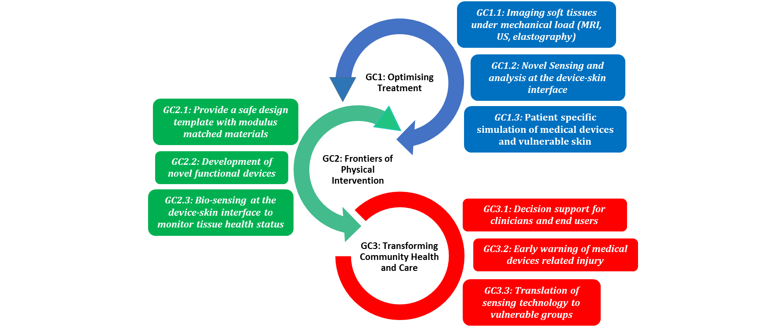

Research Detail
Description of Work
Please provide a description of the work that will be conducted during your project. If appropriate, include the relevant clinical focus for your application.

(Figures can be added – please keep this section to 1 side)
Project Deliverables
Please detail the key research outcomes from the project with timelines.

(max 250 words)
Research Dissemination
Describe how you will disseminate your research findings to an academic and lay audience.

(max 250 words)
Future Funding Strategies
Describe how the research could attract additional funding.

(max 250 words)
Costings + Resources
Please provide a detailed breakdown of costs associated with your project

(See guidance notes)
Track Record
Demonstrate the capacity of the research team to deliver the proposed research

(max 400 words)
References
Place supporting references for all sections here.

Guidance Notes

This Medical Devices and Vulnerable Skin Network funding stream is designed to support “Intelligent Sensing to promote self-management’

Remit: Our remit is broad but focused on feasibility studies which offer the potential to spawn more effective designs and performance of medical devices which will minimise trauma to vulnerable skin tissues. This will inevitably involve joint applications encompassing different sectors.

Research Novelty: You should highlight how the proposed research has the potential to lead to a significant advances in improving medical device design for specific clinical applications. Any potential commercialisation strategies should be stated.

Project Deliverables: Deliverable need to be clearly stated to match with the major research outcomes of the project.

Dissemination: We would require a firm commitment to publicise the research to the wider scientific and clinical communities. Appropriate workshop activities and public engagement is encouraged. We would expect acknowledgement of MDVSN^{PLUS} funding in all dissemination activity.

Future Funding Plans: We will assess the strategies envisaged by the applicants to extend the research using additional funding streams e.g. RCUKs, Medical Charities, NIHR and Industry.

Costing and Resources: It is important to note that the funding will not cover salary costs for any of the applicants. Funding will be provided 80% FEC, as per EPSRC standard. We will provide support up to a maximum of £20k per project (equivalent to 100% FEC of £25k). This is designed to support staff and consumables costs up to a maximum of 12 months. We will also consider smaller funds for proof of concept studies typically up to £5k per project, (equivalent to 100% FEC of £6.25k).

Assessment Procedure: All applications will be considered by a panel of Network partners with an independent chairperson. Consideration will be paid to how closely the research proposal matches to the EPSRC Grand Challenges. MDSVN^{PLUS} will consider applications in three separate calls open during its lifetime.

EPSRC NetworksPlus - Plus funding rules

Additional Grant Conditions

EPSRC has included an additional grant condition on the networks funded through this call which enables funds to be moved between headings to allow for flexibility with regard to the ‘PLUS’ funding. However EPSRC does not expect to see a large proportion of the funds to be spent on overheads/estates costs.

Moving funds between Directly Allocated and Directly Incurred headings is not normally permitted, however the funding line for ‘PLUS’ funds can be used to cover directly incurred as well as directly allocated, estates and/or indirect costs associated with carrying out the feasibility or collaboration activities the network has identified.

NB: The deadline for applications is Friday 30th March 2018
Successful applicants will be notified by Friday 27th April 2018

Please email completed applications to Fiona Brewer: f.brewer@soton.ac.uk

