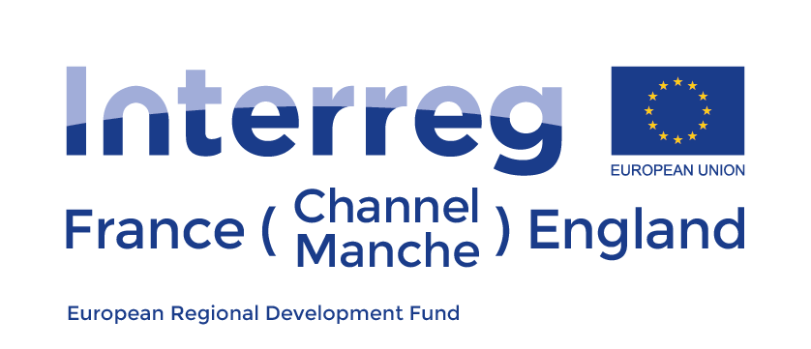

EU project to monitor Harmful Algal Blooms from space

On 21st November 2017, S-3 EUROHAB, a new environmental project under the remit of the Interreg France Channel England Programme (FCE) and co-funded by the European Regional Development Fund, was launched. The project will be funded up to 2.6 million euros over 4 years and is being led by scientists from Plymouth Marine Laboratory working in collaboration with 8 additional UK and French partners. They will use the latest satellite technology to improve the way water quality and harmful algal blooms (HABs) are monitored in the English Channel, and will assess the socio-economic implications of HABs.

Harmful Algal Blooms (HABs) are caused by excessive growth of marine algae which release harmful toxins into the water that can kill fish, shellfish and even humans when they consume contaminated fish. As a result they can have an extremely damaging effect on the tourism and fishing industries. In the EU the annual cost of HABs to these industries is estimated to be in excess of 918 million euros. Poor water quality can also affect our coastal regions, which can adversely affect a number of maritime industries.

The project known as S-3 EUROHAB will use data from the recently launched European satellite, Copernicus Sentinel 3, to track the growth and spread of HABs and phytoplankton abundance related to water quality, in the Channel. The satellite data will then be used to create a web based alert system, the first of its kind in Europe, to alert marine managers and fishing industries of the growth of potentially damaging algal blooms. Data will also be gathered to help better understand why, how and when HABs occur as well as the economic costs associated with HABs and poor water quality and how the web based alert system may reduce these costs.

Current methods of tracking HABs are inefficient and expensive, costing 2 million euros annually to monitor just 6% of the Channel area. S-3 EUROHAB’s methods will not only cost significantly less, just 42,000 euros annually, but will also cover the whole Channel area. The alert system will also result in much faster response times to HABs, potentially helping to mitigate the blooms which will help to reduce the millions of pounds lost each year as a result of HABs in both France and the UK. Improvements to existing methods will be made using satellite ocean colour data and in particular the application of the latest technological advancement in, and recent launch of, the European Copernicus Satellites. The project will use these satellite data to create a web based HAB and water quality alert system that will be designed alongside marine managers and industry end users to enhance the marine monitoring of HAB’s in the French-English Channel region.

The project budget will total 3.7 million euros with 69% funded by the Interreg France (Channel) England programme, representing a European Regional Development Fund budget of 2.6 million euros. The project is made up of 9 organisations, 5 from France (IREMER-Brest, IFREMER-Port-en-Bessin, IFREMER-Boulogne-sur-Mer, Comité Régional des Pêches de Basse Normandie Universite de Brest) and 4 from the UK (Plymouth Marine Laboratory, Environment Agency, University of Southampton, Devon and Severn Inshore Fisheries and Conservation Authority), and will run from November 2017 to October 2021.

-Ends-

For further information, please contact:

Gavin Tilstone - ghti@pml.ac.uk

Notes to Editors
- The Interreg FCE Programme is a European Territorial Cooperation programme that aims to fund high quality cooperation projects in the Channel border region between France and England. It focuses on a range of specific objectives including supporting innovation, improving the attractiveness of the FCE area and developing low carbon technologies. The Programme has a total of €223 million of ERDF funds to distribute by 2023 and is managed by Managing Authority Norfolk County Council.
- Project Partners:
  - Lead partner: Plymouth Marine Laboratory (UK)
  - L'Institut Français de Recherche pour l'Exploitation de la Mer – Brest (France)
  - University of Southampton (UK)
  - Environment Agency (UK)
  - L'Institut Français de Recherche pour l'Exploitation de la Mer – Boulogne (France)
  - Comité Régional des Pêches Normandie (France)
  - Devon and Severn Inshore Fisheries and Conservation Authority (UK)
  - L'Institut Français de Recherche pour l'Exploitation de la Mer (Ifremer) – Port-en-Bessin (France)
  - Université de Bretagne Occidental (France)
- The Programme operates within a clearly defined eligible area, covering the South and East Coasts of England from Cornwall to Norfolk, and the North Coast of France from Finistère to Pas-de-Calais. The programme area can be found here.
- More information about the Programme can be found at https://interreg5a-fce.eu/.

