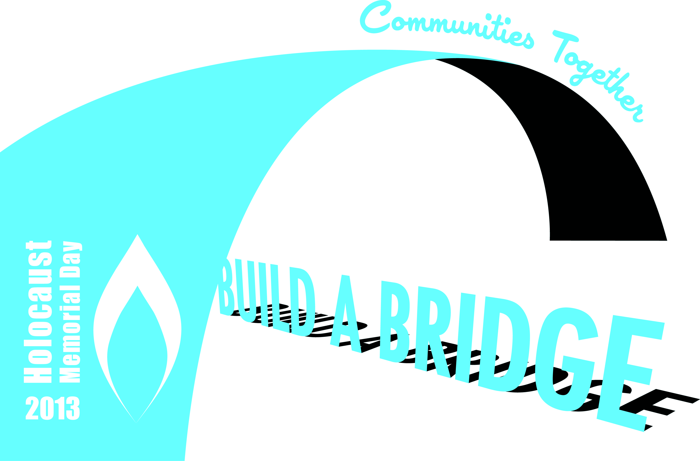

**Sir James Matthews Building, Southampton Solent University on**

**Thursday 24th January 6-7pm**

**Holocaust and Genocide Memorial Day Programme**

*This programme was organised by Tom Plant from the Parkes Institute for the Study of Jewish/non-Jewish Relations, University of Southampton*

Welcome by Phil Gibson

Introduction by Councillor Derek Burke, Mayor of Southampton

Testimony from Harry Bibring

Students from Itchen College reflect on the Holocaust

Students from the BA (Hons) Performance degree at Southampton Solent University perform "In the Vicinity of Karlsberg", a work of four voices based on the life and death of Karel Svenk, by Matt Fletcher

Retiring Collection

**Refreshments will be available directly after the event**

There will be an opportunity to talk informally with those at the event and take Holocaust Memorial Day Trust literature

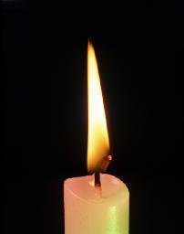

[**http://www.hmd.org.uk/**](http://www.hmd.org.uk/)

**We would like to thank all those involved in this evening’s commemoration**

**Southampton Solent University**

**The Holocaust and Genocide Memorial Day Committee**

**The Parkes Institute for the Study of Jewish/non-Jewish Relations, University of Southampton**

**\*\*\*\*\*\*\*\*\*\***

**With special thanks to**

**Phil Gibson, Head of Student Services, Southampton Solent University**

**Councillor Derek Burke, Mayor of Southampton, Southampton City Council**

**Harry Bibring, Holocaust Educational Trust**

**Rev Dr Julian Davies**

**The G. F. Forsey Fund**

**Christian Scott and Shaun O’Toole and students from Itchen College:**

**Tania Harvey, Yasmin Taylor and Natalia Kwiatkowska**

**Matt Fletcher and students from Southampton Solent University:**

**Igor Hiszczynski, Zak Jalil, Ashley Racov and Jennifer Skeats**

**Dr Shirli Gilbert, Dr James Jordan and English and History students from the University of Southampton:**

**Lauren Showler, Steph Woodhouse, Abbie Collard, Alex Brown, Faye Hotchen, Olivia Phipps, Jade Hearne, Holly McCullough, Carla Yorukoglu, Sarah Smyth, Jared Anderson, Sophie Butler, Kelly Weaver, Coral Abraham, Hannah Corkerry, Zoe Steele, Alex Rowley, Charlotte Moxham.**

